**ASSISTED PRACTICE (XPATH AND COMPARISON ASSERTIONS)**

XPATH ASSERTION:

Step1: Open Jmeter

Step2: Right click on HTTP request that we have created in XML Assertion -> Add -> Assertions -> Xpath Assertion

Step3: In Xpath Assertion -> Give “/note/from” in Validate Xpath Assertion section -> Save it

Step4: Execute it to see the output

In View Results Tree:

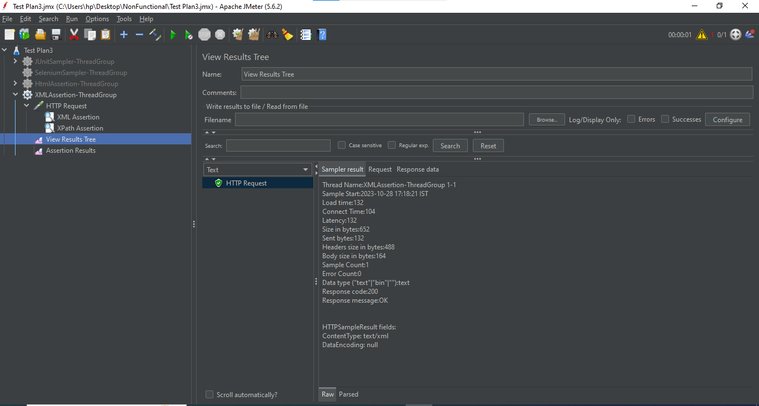

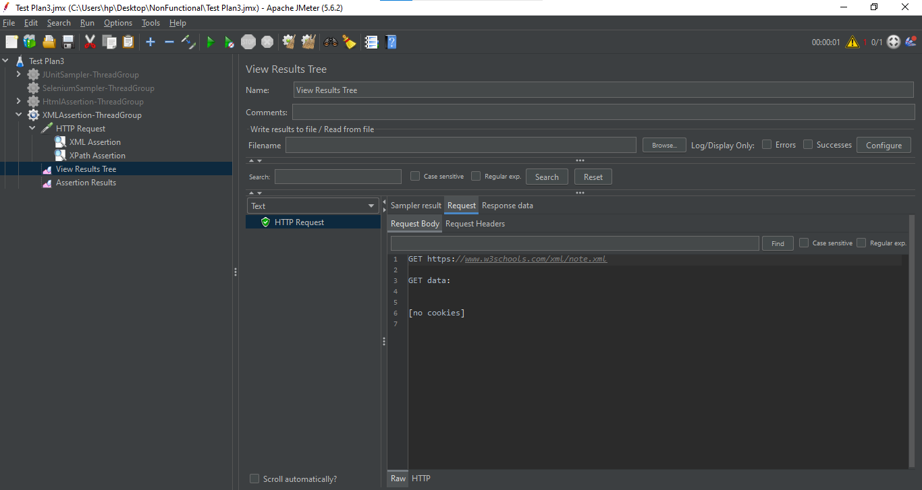

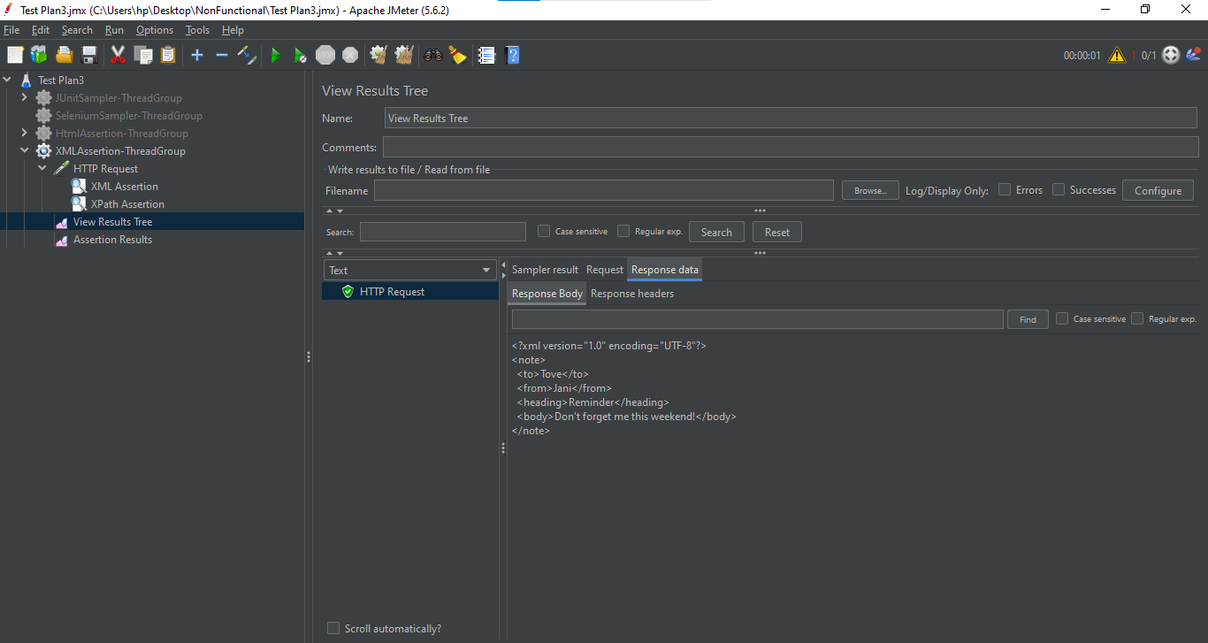

In Assertion Results:

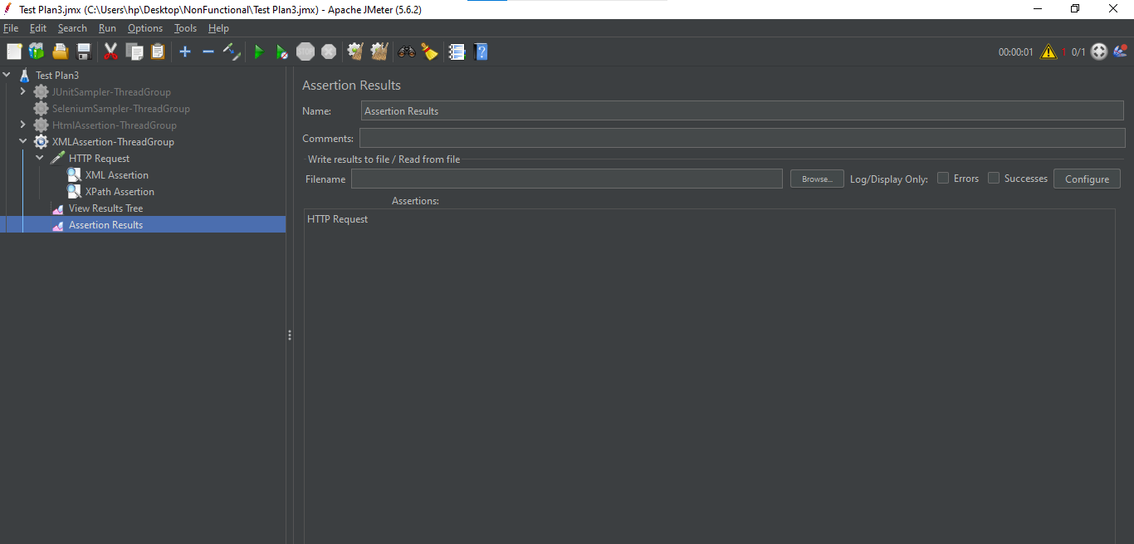

COMPARISON ASSERTION:

Step1: Open Jmeter -> Add Thread Group

Step2: Right click on Thread Group -> Add -> Sampler -> Add two HTTP request in this Thread Group

Step3: In both HTTP request -> Give protocol as “https” and server as “[www.google.com](http://www.google.com)”

Step4: Right click on Thread Group -> Add -> Assertions -> Compare Assertion

Step5: Right click on Thread Group -> Add -> Listener -> View Results Tree

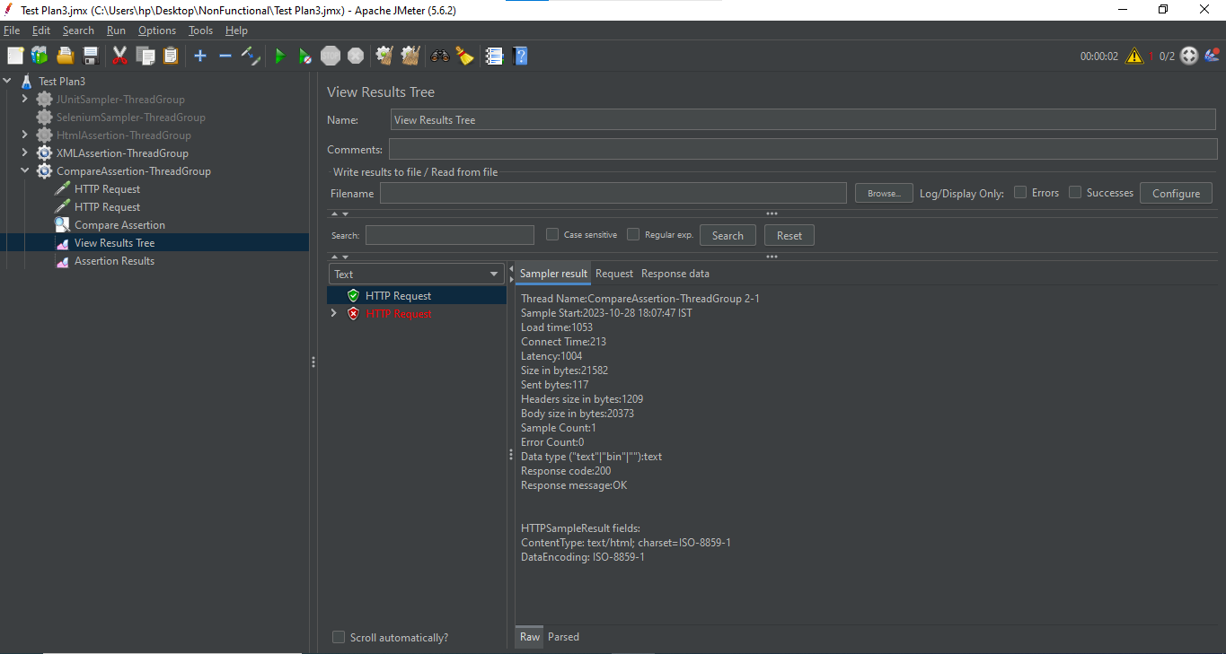

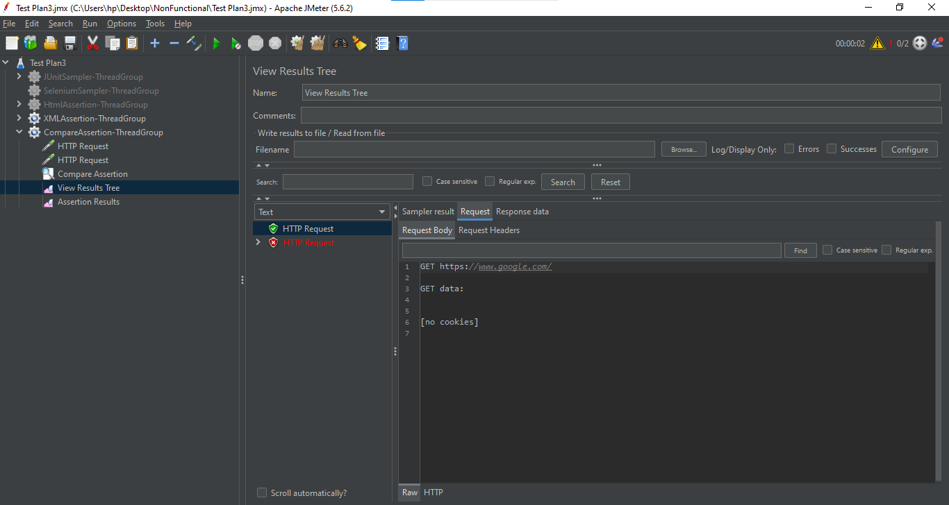

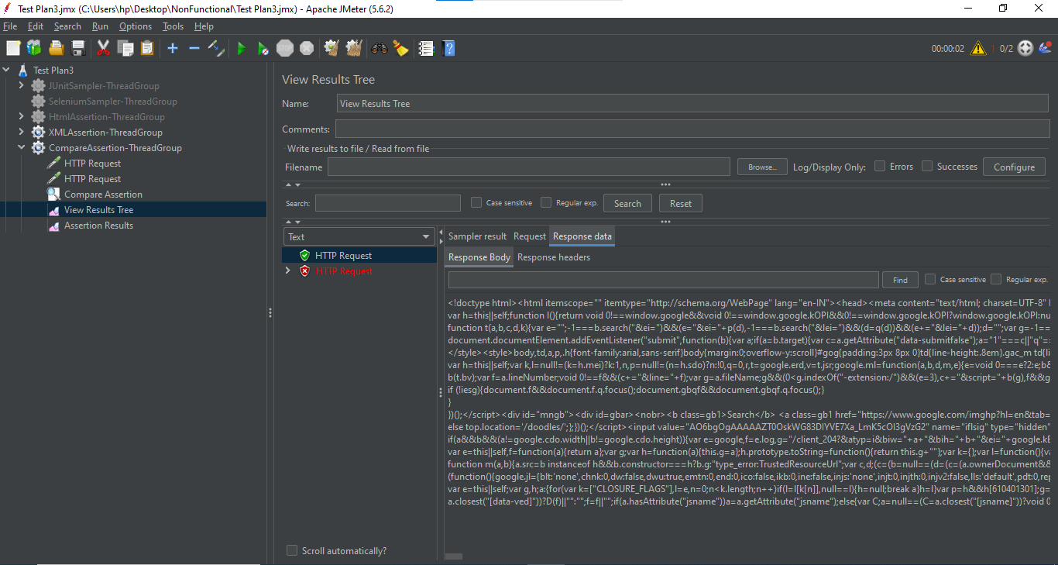

Step6: Right click on Thread Group -> Add -> Listener -> Assertion result

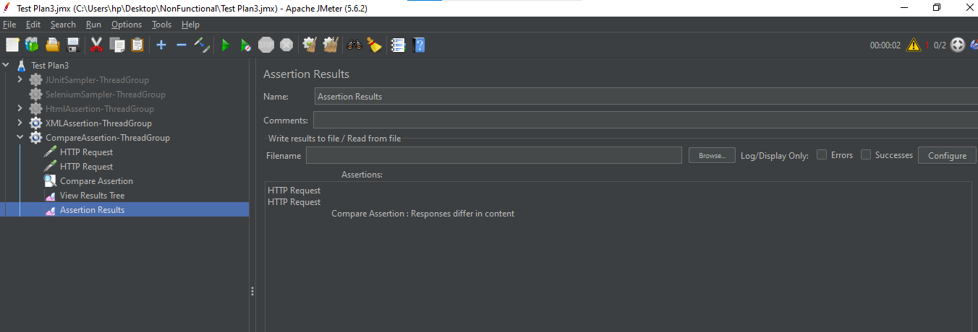

Step7: Right click on Thread Group -> Add -> Listener -> Comparison Assertion visualizer

